### In order to add a picture, use "Add Existing Item"

Image image = new Image() { }

Image - Class, contains constructors & methods

image - identifier

new keyword - explicitly hides a member that is inherited from a base class

Image() - Constructor method

{ } - will contain constructor arguments such as path

{ Source = new BitmapImage(new Uri(“pathToFile”,UriKind.Relative))};

New Windows

Project Menu - Add Window

**Methods:**

**private bool CheckCollisionOfTwoRects(Rectangle player, Rectangle enemy)**

**{**

**Rect playerRect = RectConverter(player);**

**Rect EnemyRect = RectConverter(enemy);**

**bool intersect = playerRect.IntersectsWith(EnemyRect);**

**if (intersect)**

**{**

**return true;**

**}**

**return false;**

**}**

**private Rect RectConverter(Rectangle rectangle)**

**{**

**Rect rect = new Rect();**

**rect.Height = rectangle.Height;**

**rect.Width = rectangle.Width;**

**rect.Y = Canvas.GetTop(rectangle);**

**rect.X = Canvas.GetLeft(rectangle);**

**return rect;**

**}**

**Objectives**

* Initialisation
  + Allows player to either start a new game or continue a saved game from a previously exported savestate file
  + In a new game:
    - Allows player to input a maximum 8 character name, which will be used in dialogue and leaderboard of farthest runs
    - Allows player to customise stats using a point-buy system
      * All stats start at 10 and the program grants the user 10 stat points to allocate, where each point is worth one stat point in any given stat. Without relics, the maximum stat value is 20.
    - Allows player to choose a class, either warrior, archer, mage or thief
      * Class determines proficiencies, possible weapons and a trait, with warrior trait providing damage mit, archer providing crit chance, mage providing damage and thief providing move speed and more starting money
      * class determines starting weapon choices
      * Warrior
        + High health, high armor, less damage potential
      * Archer
        + Moderate health moderate armor, ammo management
      * Mage
        + Low health low armor high damage
      * Thief
        + Low health low armor low damage, gets more money per kill
    - Character starts at level 1, levels up every 3 rooms (1 floor)
      * Each level provides +1 to a stat, as well as potential access to a new trait/skill
  + From savestate
    - Reads a given file
      * First, checks 5 char header to identify if the file is a file for the game (##~##)
      * Imports character by reading file
        + Imports stats same way as initialisation does, by reading to a list which is passed as a parameter
        + Class after hp
        + Imports inventory into array, start and end indicated by []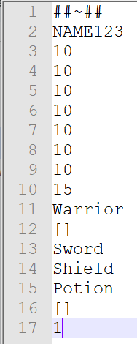
        + Current floor recorded, but not room
        + File follows format =>
      * After file is read, generates level as usual, but starts

from floor indicated by line 17

* In game
  + After creating/importing character:
  + Generates room from a set of predetermined layouts at random, with

smaller and more difficult rooms spawning with a higher likelihood

at higher levels

* + - Follows structure Fight, Fight, Fight, Store (loops)
    - Clearing a fight room rewards a new item, which you can

swap into your inventory as well as money to spend at the store

* + - Difficulty increases as you play
      * Examples include increasing enemy hp, more

enemies or stronger bosses

* + - Every 3rd full floor (9 fight rooms) is a boss with more hp,

more advanced attacks and better rewards

* + Fight rooms
    - Fight rooms contain a number of enemies whose health is influenced by difficulty setting and floor, with the general formula being

Enemies = 5; Hp = 0.75 * 2^{0.5x}

where Floor is the current floor and difficulty is the modifier provided by the difficulty, with easy being 0, medium being 1 and hard being 2.

* + - Every enemy killed drops 1 money and every room drops either a healing potion or money determined by Money = Floor * Mod, where Mod is a random value from 0.80 - 1.50 inclusive.
  + Shop rooms
    - Shop rooms provide the opportunity to spend money to buy items (Weapons, Armor, Consumables & Relics)
    - Cost of an item is based on the formula

Price = [5 * Floor] * RarityMod * DifficultyMod * ConsumableMod

where RarityMod is the modifier determined by the rarity of the item (Common = 1x, Rare = 1.1x, Epic = 1.25x, Legendary = 1.5x and Unique = 2x) and difficultyMod being the modifier for difficulty (1x for easy, 1.25x for medium and 1.5x for hard), and consumableMod being 0.5x if the item is a consumable or 1.25x if the item is a relic. Using the formula, an Epic Sword on floor 5 at difficulty Hard would cost 46.875 ([5 * 5] * 1.25 * 1.5) money, rounded to 47 money.

* + Boss Rooms
    - Each boss room has the same layout, which is slightly larger than the normal rooms
    - Bosses are stronger, tankier enemies with a unique gimmick.
      * Example Boss: Hook Orc
        + Hook Orc has a special attack where he throws out a hook at the player. If the hook hits, the player is instantly pulled to the boss and takes an enhanced melee hit
    - Upon killing a boss, drops 10 money and a randomly generated item (minimum epic rarity)
  + Tough boss rooms
    - A tough boss room spawns every 6th floor on easy, 9th floor on medium and 15th floor on hard
    - To “win” the game, the player must defeat a tough boss
  + Combat
    - Players will have to fight off enemies in a room before being able to advance.
    - Weapons will have “hitboxes” to check whether an enemy has come into contact with
* Starting items (basic):
  + Sword - moderate (2) damage, moderate (2) range, moderate (1) attack speed
  + Spear- low damage (1), high range (3), very high (0.5) attack speed
  + Greathammer - high damage (5), high range (3), very low (2) attack speed
  + Magic Wand - moderate (2) damage, moderate (2) mana, moderate (1) attack speed
  + Staff - high (5) damage, high (5) mana, moderate (1) attack speed, has a quickmelee (low (1) damage melee attack to avoid penalty for casting spells in melee combat)
  + Tome - low (1) damage, low (1) mana, very high (0.333) attack speed
  + Bow - high (3) damage, good (5) range, low (1.5) attack speed
  + Crossbow - low (1) damage, moderate (4) range, high (0.667) attack speed
  + Javelins - moderate (2) damage, lower (3) range, moderate (1) attack speed
  + Throwing Knife - low (1) damage, low (1) range, moderate (1) attack speed
  + Caltrops - high damage (3), very low (0.5) rance, very low (2) attack speed
  + Sling - low damage (1), moderate (1) range, moderate (1) attack speed
* Example relic: Large Quiver
  + Prerequisites: Class = Archer
  + Increases MaxAmmo by 5 which means you have to reload less often
  + Rarity - Rare
  + Blessed - MaxAmmo increases by 10 instead
  + Cursed - Damage increases by 1 for all ranged attacks
* Example relic 2: Flaming Sword
  + Prerequisites: Class = Warrior
  + Adds Fire damage to attack, meaning each attack deals more damage
  + Rarity - Rare
  + Blessed - Replaced with Holy Fire Sword, which deals extra damage vs skeletons.
  + Cursed - Replaced with Cursed Fire Sword, which applies Burn status effect, reducing enemy defense by 5% per stack, max 3.
* Example Consumables
  + Small Potion (Health)
    - Heals for 10hp
    - No drawbacks
  + Bomb
    - After a 1.5s fuse, detonates and deals 3 damage
* Create a C library to run calculations and import it as a .dll into my .csproj

Initial modelling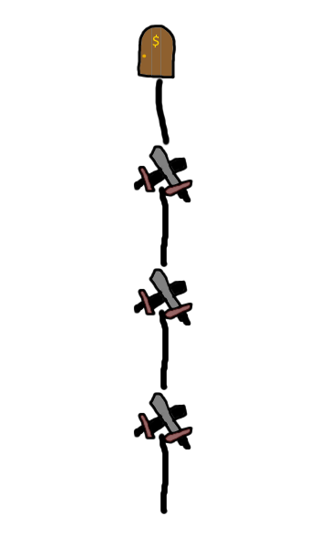

The game will be a 2d top-down view roguelike dungeon crawler (a game where you fight through procedurally generated rooms). The game is split onto “floors”, where each floor consists of 4 rooms, 3 combat rooms and one special room. Unless the floor number is a multiple of 3 or is a “Tough Boss Floor”, the special room is a shop, where the player may spend money harvested from combat rooms.

Shown on the left is the basic layout for rooms. The clashing swords represent a combat room, while the door with a dollar symbol represents the shop.

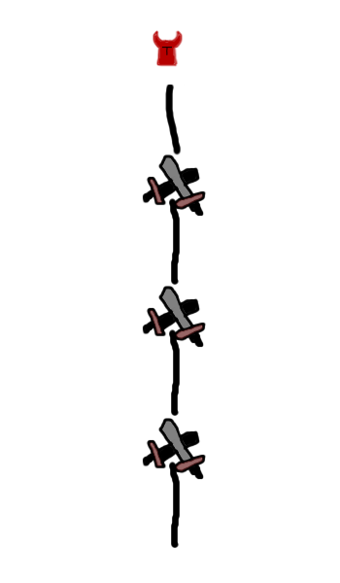

Every three floors, the special room will be a boss room. After three combat rooms, the player will have to fight a boss, which is a single strong enemy with a special mechanic. For example, a boss’s gimmick might be an attack in which it throws a hook and attempts to reel you in, stun you and deliver a powerful attack. Killing a boss rewards the player with more money than killing normal enemies, and bosses are guaranteed to drop new items, with a minimum Epic rarity. This ensures players feel that killing bosses is worthwhile. After clearing the boss room, the player is permitted to go to the shop before facing the next three combat rooms.

A tough boss room will spawn at a lower frequency than a normal boss room. A tough boss room spawns every 6th floor on easy, 9th floor on medium and 15th floor on hard. This is to force the player to fight more rooms before the final fight on a higher difficulty level, thus making the overall game more difficult as there is a higher potential for mistakes. After three combat rooms, the player will have to fight a “Tough” boss. The tough boss room is larger than a normal room to allow the player more chances to dodge attacks. Tough bosses will have specific attack patterns, with intricate “bullet hell” phases. These are designed to force the player to focus on dodging rather than raw damage alone. 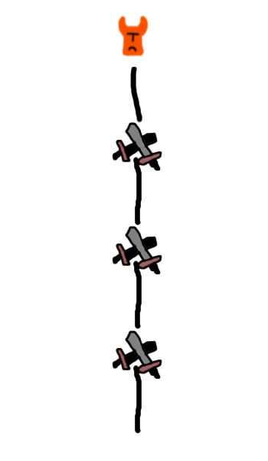

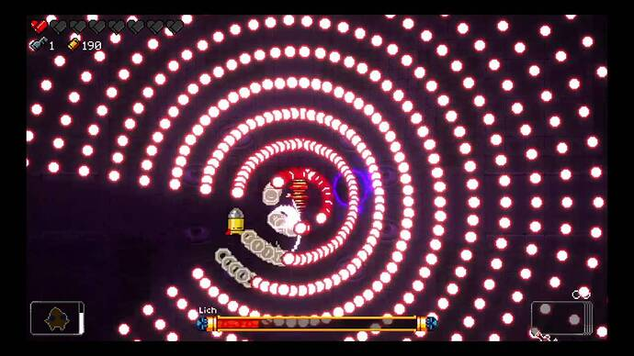

Example to the left. This particular bullet hell tests the player’s reaction time to move to the area with no projectiles rather than attempt to dodge individual projectiles. An alternative bullet hell might be a constant spray of bullets which track the player and force them to keep moving.

Scoping:

* MaximumEnemiesOnScreen - Probably ~5 to limit the maximum render requirements in order to ensure that the game is able to be run and debugged without issue - 5 on screen at once
* TotalNumberOfItems - A common, rare, epic, legendary and Unique variant for each weapon (60 items), a variety of potions (buffs for each stat (8), hp restore (3) and mana restore (3)) - 74 total different items
* TotalNumberOfRelics - Relics are rarer items that provide buffs to a character. Similarly to items, there are variants per relic but these are limited to the base relic, a blessed relic and a cursed relic. This leads to a total of 60 relics total, 40 of which are clones with slightly different effects from the base relic.
* NumberOfDifferentEnemies - There will be 4 base enemy types (goblin, skeleton, zombie and cultist), but each of these enemies has a class (warrior, archer, mage and tank), providing 16 different enemies. Each of these enemies will have a selection of 3 different weapons, providing 192 different enemies
* NumberOfBossEnemies - There will probably be in the region of 20 bosses to provide lots of variety to runs.
* PlayerStats
  + HP
    - HP will increase on level up. The starting HP for all classes is 10, but all classes apart from the warrior class will gain 5 more hp per level. The warrior will instead gain 8 hp per level as a melee class.
  + Str, Dex, Con, Int, Wis, Cha & San
    - The stats of the player start at 10. The player is also granted 10 points on starting the game to increment the stats, with a maximum of 20 points in each stat. When levelling up, the player also gains a +1 to a stat of their choice. Some weapons will also have a strength requirement (likely 13, 15 or 20) to make sure that a speed build cannot exploit heavy, two handed weapons.
  + Mana
    - Mana points are only available for the Mage class. Mana is restored slowly over time or instantly using potions. The initial mana restoration rate is 10 mana per second ($10Ms^{-1}$), but this can be increased by the Intelligence stat, with each point allocated to intelligence providing $1Ms^{-1}$ more mana regeneration. There will also be a relic which provides 2x mana regeneration (1.5x with a damage boost if cursed, 1.5x with a heal over time (HOT) effect if blessed)
* Shopping - Cost of an item is based on the formula

Price = [5 * Floor] * RarityMod * DifficultyMod * ConsumableMod * RelicMod

where RarityMod is the modifier determined by the rarity of the item (Common = 1x, Rare = 1.1x, Epic = 1.25x, Legendary = 1.5x and Unique = 2x) and difficultyMod being the modifier for difficulty (1x for easy, 1.25x for medium and 1.5x for hard), consumableMod being 0.5x if the item is a consumable and 1x otherwise, and RelicMod being 1.25x if the item is a relic and 1x otherwise. Using the formula, an Epic Sword on floor 5 at difficulty Hard would cost 46.875 ([5 * 5] * 1.25 * 1.5 * 1 * 1) money, rounded to 47 money. Similarly, a Unique Bow on floor 10 on hard difficulty would cost 150 ([5 * 10] * 2 * 1.5 * 1 * 1) money.

* Money - Money is an important resource for roguelikes. The player character will have the ability to collect money from defeating enemies and looting chests. Every enemy killed drops 1 money and every room drops either a healing potion [(lv 1 (10hp), 2 (15hp) or 3 (25hp) where $lv = \sqrt{PlayerLevel}$)] or money determined by Money = 3 * Floor * Mod, where Mod is a random value from 0.80 - 1.50 inclusive. Players will gain interest on money saved ($1 per $10 in wallet) in order to incentivize skilled gameplay and not rerolling every shop and buying every weapon
* Levels - There will be theoretically infinite unique levels as levels will be constructed from “tiles” created beforehand. These “tiles” will be procedurally assembled into new levels for the player to fight in. There will be collections of levels called “floors” which are milestones for player progression, where the game can be won after a certain amount of floors determined by difficulty, with easy needing 6 floors, medium needing 9 floors and hard needing 15 floors.
* Tiles - There will need to be a variety of tiles in order to construct the required rooms. As such, there should be:
  + at least 4 corner tiles (TL, TR, BL, BR)
  + three varieties of wall tile (e.g. brick, stone, wood)
  + a selection of floor tiles, with brick, stone and wood and each having pattern variants, for a total of 12 different floor tiles
  + an entrance door tile and an exit door tile
  + boss room tiles
    - 4 new corner tiles
    - 2 kinds of wall time (horizontal and vertical)
    - one kind of floor tile
    - entryway and exit tiles

Enemies:

| Name | Features |
| --- | --- |
| Goblin | Fast moving, low health, low damage enemy. Two goblins take one enemy slot in a room, making a maximum of 10 goblins in a room. |
| Skeleton | Slow moving, ranged, moderate damage, low health enemy. Skeletons can have variant arrows, such as poison arrows or slow arrows. |
| Orc | Slow moving, high health, moderate damage enemy. Orcs cannot take damage until all goblins are defeated. Maximum one Orc per room. |